

Volunteer Registration Form

To be completed by the volunteer’s Club/School supervisor

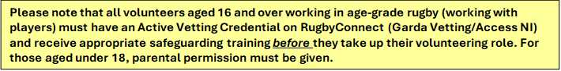

Volunteer name: _______________________________
Email address: __________________________________
Mobile number: _________________________________
Date of birth: ______/______/____________
Club/School name: _____________________________________________________
Volunteer role: _________________________________________________________
Start date: _____________________________________
Finish date (if applicable): _________________________

- I confirm that this volunteer will be supported to complete their volunteer hours record sheet. I/we have identified someone from within the club/school to provide this support and to confirm the volunteer’s record of hours. Yes o (please tick)

- I confirm (where applicable) that this volunteer has an Active Vetting Credential on RugbyConnect and has received the appropriate safeguarding training, with parental permission where required. Yes o (please tick)

Volunteer Supervisor name and surname_________________________________________
Signed: ___________________________________________
Date: ____________________________________________
Role within the club/school: __________________________
Email: ____________________________________________
Contact number: ___________________________________

Once completed, please return this form to:
nicci.wilson@ulsterrugby.com

